Hello All!

I know am posting towards the fag end of the course, but it is due to a realization that happened pretty late. I was watching **The Dark Knight** last night on HBO for the (I-lost-count)th time and realized that the Joker's 'social experiment' with the people on the 2 ferries is nothing but **Prisoner's Dilemma**! I searched online and found a myriad articles explaining the game theoretic aspects of the scene. Here's a youtube link for that:

**Scene Description:** There are 2 ferries on the waters of Gotham. One, say ferry A, has ordinary citizens and the other, B, has Gotham's notorious criminals on board. The Joker wires both of them with explosives and leaves the detonator of A with B and vice versa. He then tells them that if either of them push the detonator and make the other ship explode, they can survive. It is now left to the people in the respective ferries to arrive at a decision.

The Actions are {Stay Quiet, Detonate}

The preferences over the action profile would look like:

For Ferry A: {(Detonate, Stay Quiet) > (Stay Quiet, Stay Quiet) > (Detonate, Detonate) = (Stay Quiet, Detonate)}

For Ferry B: {(Stay Quiet, Detonate) > (Stay Quiet, Stay Quiet) > (Detonate, Detonate) = (Detonate, Stay Quiet)}

Since each player would not exactly know what the other player is going to choose, their action should factor in all possibilities. Therefore this is a Simultaneous game and the payoff table looks like:

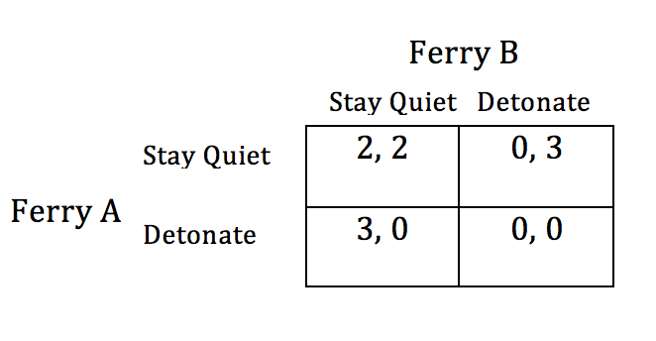

For Ferry A, both the strategy profiles: (Detonate, Detonate) and  (Stay Quiet, Detonate) gives zero payoff, similarly for Ferry B both (Detonate, Detonate) and (Detonate, Stay Quiet) gives zero payoff. This is true because I am assuming that since both the outcomes would mean that that ferry explodes, one is not very different from the other.

But if we were to take moralistic view then we can see that for ferry A, (Stay Quiet, Detonate) > (Detonate, Detonate) because even though the other ferry is choosing detonate and letting us die, we will have the moral satisfaction that we stayed quiet and did not do what was wrong! In the same way, for ferry B (Detonate, Stay Quiet) >  (Detonate, Detonate).

We can see that (Detonate, Detonate) is the Nash Equilibrium state here, but it is clearly not strict equilibrium as it is not a strongly dominating strategy. Let us see how. Suppose if Ferry A chooses Detonate, then Ferry B can choose between Detonate and Stay Quiet and both of them will give the same payoff of zero. So Ferry B is indifferent between the 2 choices here.

But again, if "Staying Alive" or "Not Staying Alive" are the only two actual payoffs here, then we could model the game differently as below:

For Ferry A: {(Detonate, Stay Quiet) = (Stay Quiet, Stay Quiet) > (Detonate, Detonate) = (Stay Quiet, Detonate)}

For Ferry B: {(Stay Quiet, Detonate) = (Stay Quiet, Stay Quiet) > (Detonate, Detonate) = (Detonate, Stay Quiet)}

And the corresponding payoff matrix looks like:

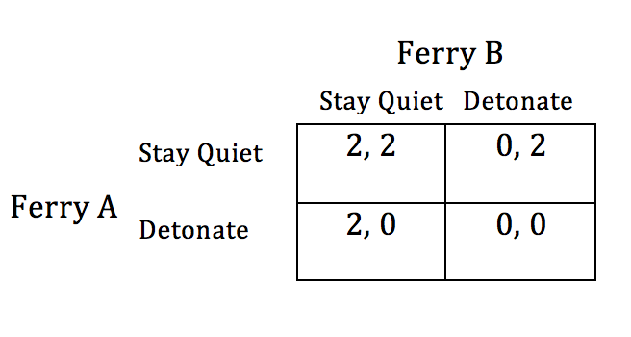

Again here also there is no strict Nash equilibrium. But we can see that now (Stay Quiet, Stay Quiet) is also a Weak Nash Equilibrium state (in addition to (Detonate, Detonate) which is also another Weak Nash Equilibrium)).

**Other Game Theoretic Concepts from this scene:**

1. **Voting:** In the Ferry A with good old citizens of Gotham, they put this issue to **Popular Vote**, whereas in the Ferry B with the criminals, the authorities assume that the criminals don't have a say in deciding if they got to live or not and take charge of the situation. So the "social choice" will reflect the preferences of these few authorities, hence this models the "**Dictatorial**" voting scheme.

2. **Trolley Problem:** Although the people in Ferry A vote to detonate the Ferry B, none of them are willing to take the lead and push the button on the detonator. We studied about a similar situation in the Trolley problem. Though they acted rationally, none of them wanted to be directly responsible for killing the people on board the other ferry.

3. **Evolutionarily Stable Strategy:** Contrary to the Joker's belief about the inherent goodness in people, the people of Gotham on both the ferries take a stand to Stay Quiet and Not Detonate the other ferry. Though this is not a repeated game, it hints to us what the evolutionarily stable strategy here is: that Gotham ranks morality above everything else, even staying alive. There is a small fraction of people on both ferries who think that detonate is the right choice and try to persuade others also to adopt their view, but eventually the ESS wins.

The reference given below lists other game theoretic aspects from The Dark Knight as well, including the Pirates Game and One Step Negotiation (Ultimatum Game). Watch the movie and see if you could come up with more such instances.

Reference: [http://www.denofgeek.com/movies/the-joker/39273/the-dark-knight-the-joker-and-game-theory](http://www.denofgeek.com/movies/the-joker/39273/the-dark-knight-the-joker-and-game-theory" \t "_blank)

Regards,

Chella

Thanks for pointing out the mistake, Gayathri! You are right. I think I muddled up two different thought processes there. So let me clear things up. I wanted to analyze the game in 2 ways:

1. When Morality is more important than Survival:

The preferences over the action profiles will be:

For Ferry A: {(Stay Quiet, Stay Quiet) = (Stay Quiet, Detonate) > (Detonate, Detonate) > (Detonate, Stay Quiet)}

For Ferry B: {(Stay Quiet, Stay Quiet) = (Detonate, Stay Quiet) > (Detonate, Detonate) > (Stay Quiet, Detonate)}

Reasoning for the above preferences: Let’s consider Ferry A’s preferences.

I have ranked the first 2 choices equally because in both of them I choose to Stay Quiet. I am upholding my moral values by staying quiet. So to me, the payoff that I obtain should be the same as the payoff here talks only about Morality.

Now consider the 3rd and 4th choices: (Detonate, Detonate) > (Detonate, Stay Quiet). In both these cases I am choosing Detonate, but can I say that -choosing to Detonate the other ferry when the other ferry also chooses to Detonate me-is less morally reprehensible than say-choosing to detonate the ferry B when those people stay quiet!

And the strategic game matrix will be:

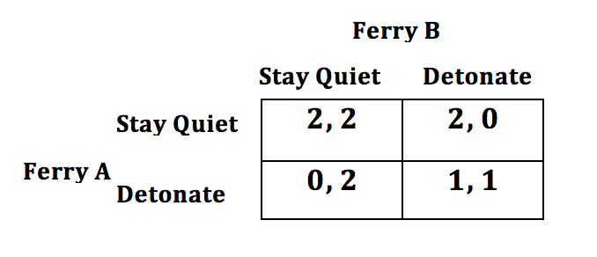

|  |  |
| --- | --- |
| **2, 2** | **2, 0** |
| **0, 2** | **1, 1** |

In this case (Stay Quiet, Stay Quiet) is the only Nash Equilibrium state (the one that Gotham chose!) But now I notice that after factoring in morality, this game is not Prisoner’s Dilemma anymore! There is no rational incentive to Defect (or Detonate in this case).

1. When Survival is more important than Morality:

This is the same as the second type of situation that I had mentioned in the original post.

**Detonate**

**Stay Quiet**

**Ferry B**

**Ferry A**

**Detonate**

**Stay Quiet**